Operating Systems Lab
Spring-2026



Lab Project

M Saim Naveed | 24F-3043
Ahmed Naeem | 23F-3113
Mohsin Ali Shah | 24F-0014

Booting OS

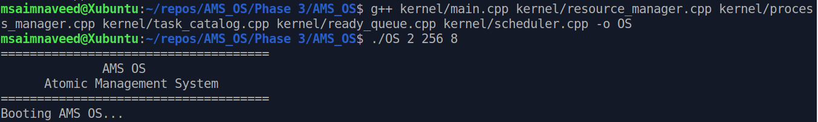

OS LOADED

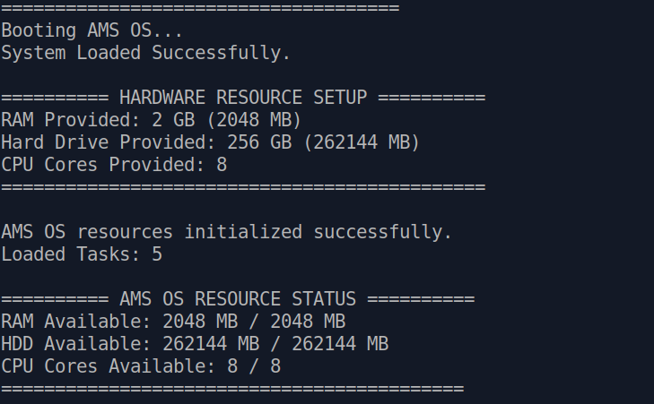

OS_MENU
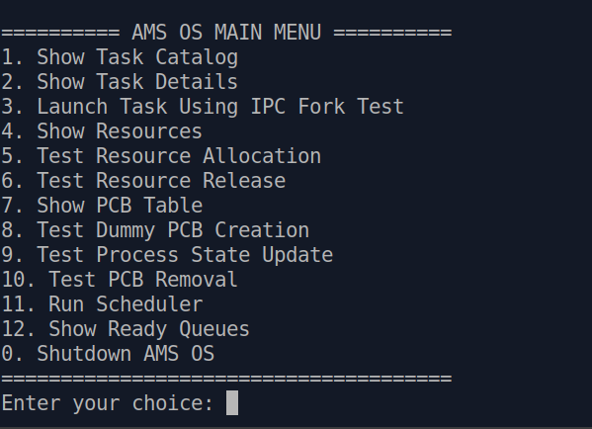

Task Manager
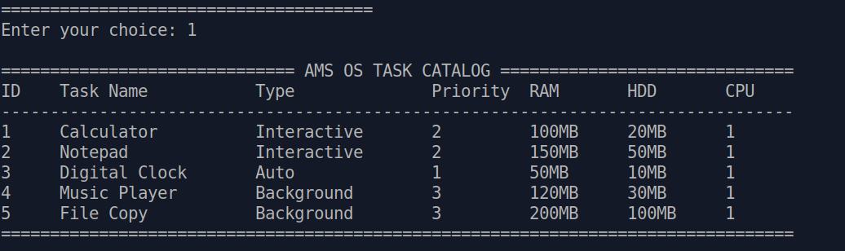

TASK CATALOG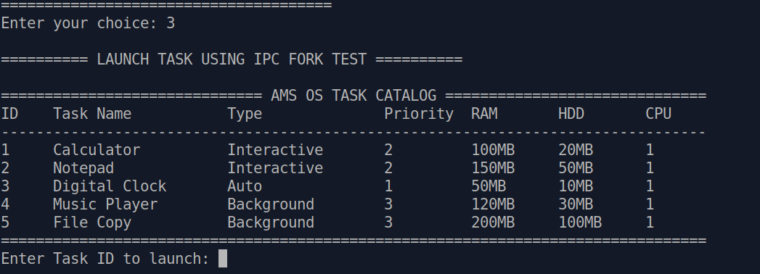

IPC resource request
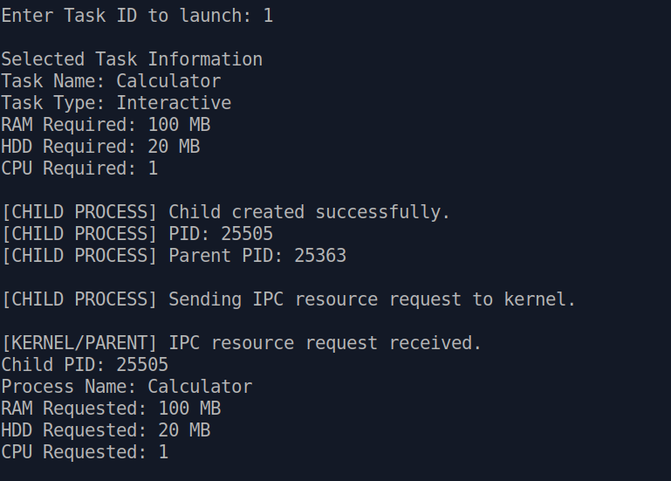

PCB CREATION AND RESOURCE ALLOCATION
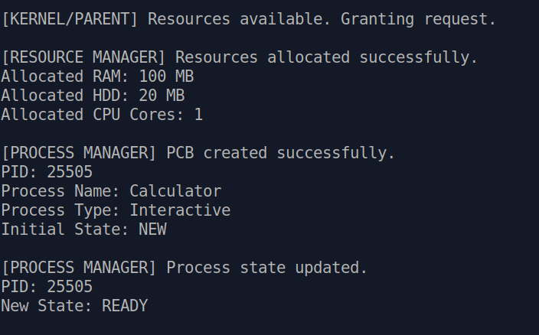

Ready Queue Display
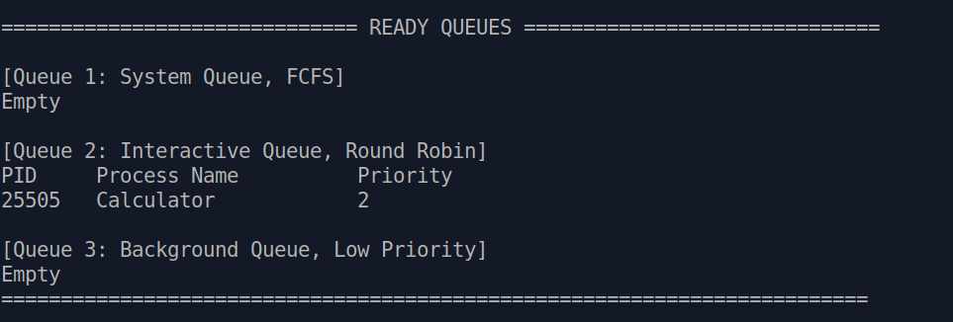

Opening 2 files and than showing PCB state
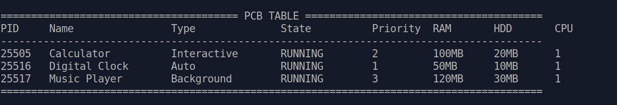

Schduler Executing files
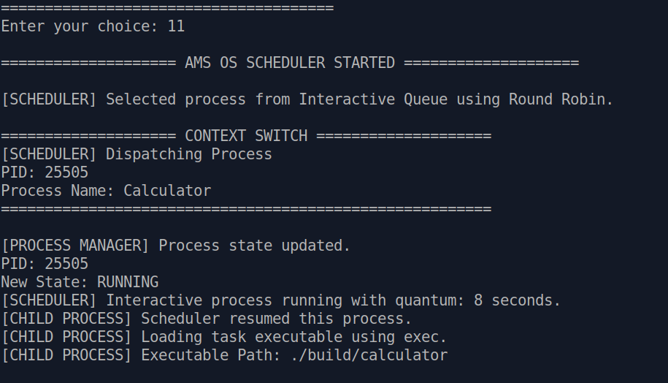
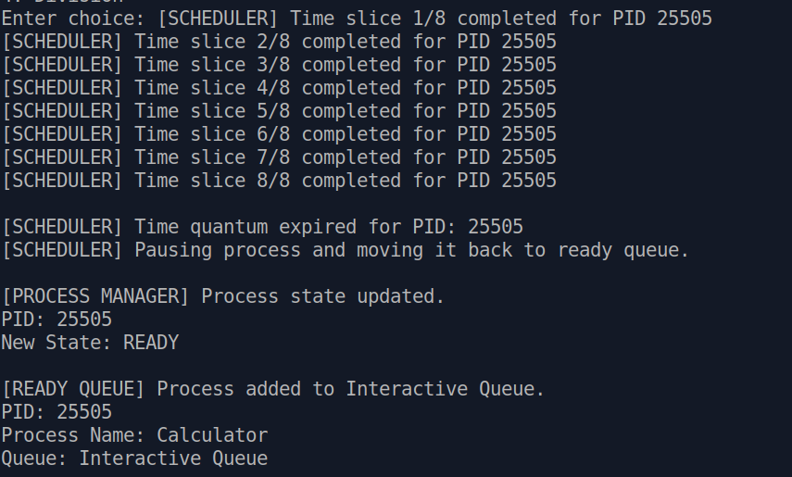

CALCULATOR Executing

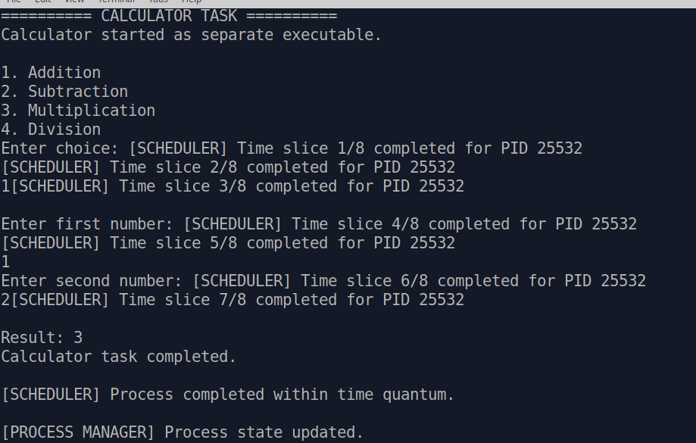

READY QUEUE AFTER ALL TASKS COMPLETED
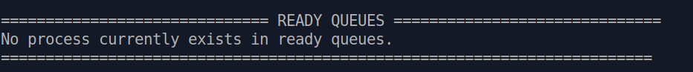

System Time
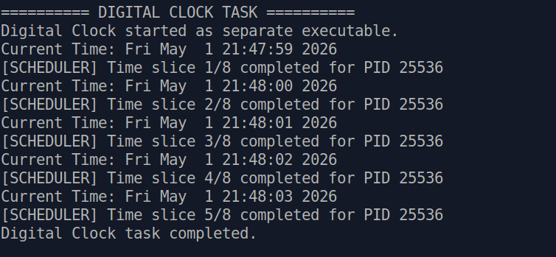

Shut Down
